 British Value – Democracy 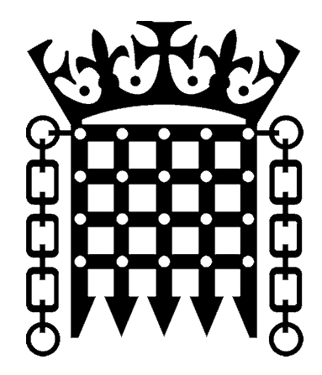
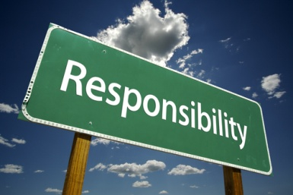 We have responsibilities in the classroom and around the school.

British Value – Democracy
 We have a voice that is listened to.
British Value – Democracy
 We work collaboratively and work in teams both within and outside the classroom.
British Value – Democracy
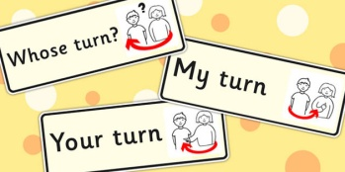 We understand about turn taking and listening to and respecting the views of others.

British Value – Democracy
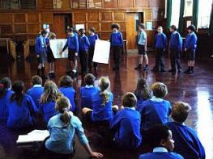 We work co-operatively across classes and year groups at playtime and through
extra-curricular activities.

British Value – Rule of Law 
 We are used to debating and discussing laws/rules and their application.
British Value – Rule of Law
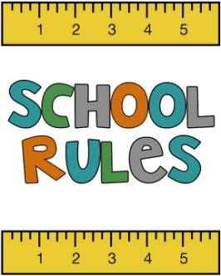 We are involved in creating rules for the classroom and the playground.
British Value – Rule of Law
 We are able to articulate how and why we need to behave in school and demonstrate we understand and can follow the rules.
British Value – Individual Liberty
 We are developing independence in our learning.
British Value – Individual Liberty
 We are able to think for ourselves and to share our views.
British Value – Individual Liberty
 We know that everyone has the right to their own thoughts and evidence based views.
British Value –  Mutual respect and tolerance of those with different faiths and beliefs.
 We understand that the freedom to choose and hold other faiths and beliefs is protected in law.

British Value – Mutual respect and tolerance of those with different faiths and beliefs.
We understand that respect is a core value, that people having different faiths and beliefs must be accepted and tolerated.

British Value – Mutual respect and tolerance of those with different faiths and beliefs.
 We understand that respect is a fundamental school value that underpins everything we do, both in and outside the classroom.

